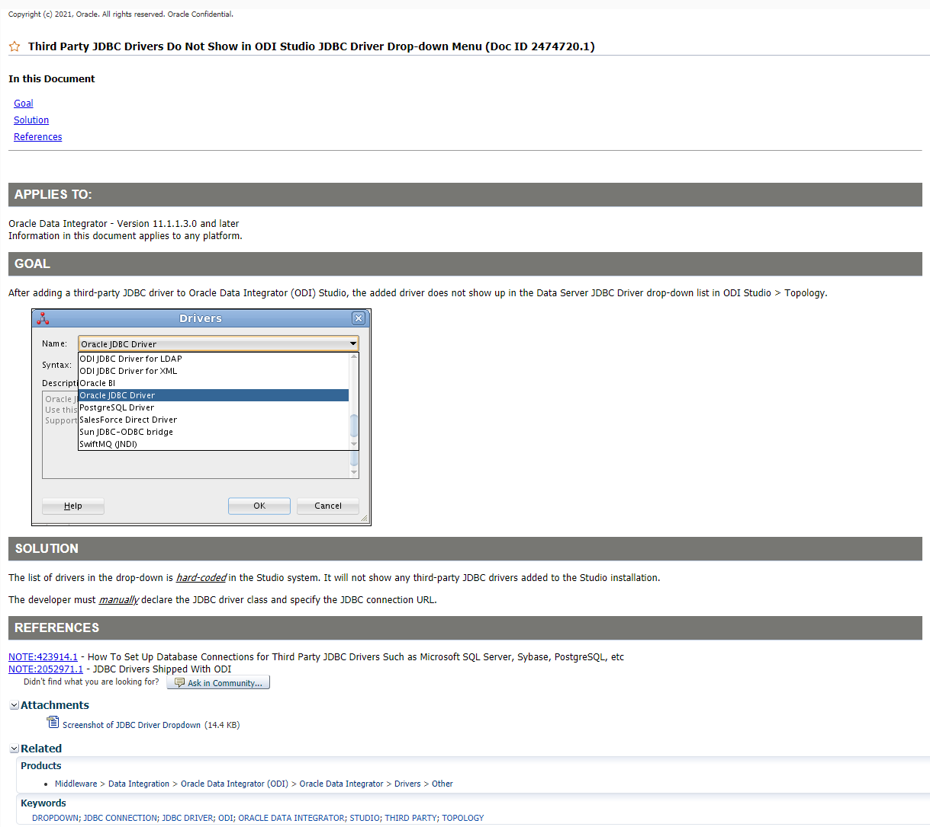

[Skip to content](https://support.oracle.com/epmos/faces/DocumentDisplay?_adf.ctrl-state=fz516ymtt_53&id=423914.1)

|  |  |  |  |  |  |  |  |  |  |  |  |  |  |  |  |  |  |  |  |  |  |  |  |  |  |  |  |  |  |  |  |  |  |  |  |  |  |  |  |  |  |  |  |  |  |  |  |  |  |  |  |  |  |  |  |  |  |  |  |  |  |  |  |  |  |  |  |  |  |  |  |  |  |  |  |  |  |  |  |  |  |  |  |  |  |
| --- | --- | --- | --- | --- | --- | --- | --- | --- | --- | --- | --- | --- | --- | --- | --- | --- | --- | --- | --- | --- | --- | --- | --- | --- | --- | --- | --- | --- | --- | --- | --- | --- | --- | --- | --- | --- | --- | --- | --- | --- | --- | --- | --- | --- | --- | --- | --- | --- | --- | --- | --- | --- | --- | --- | --- | --- | --- | --- | --- | --- | --- | --- | --- | --- | --- | --- | --- | --- | --- | --- | --- | --- | --- | --- | --- | --- | --- | --- | --- | --- | --- | --- | --- | --- | --- |
|  |  | Copyright (c) 2021, Oracle. All rights reserved. Oracle Confidential.       |  | | --- | |  | |  | **How To Set Up Database Connections for Third Party JDBC Drivers Such as Microsoft SQL Server, Sybase, PostgreSQL, etc (Doc ID 423914.1)** |  |      |  |  |  |  |  |  |  |  |  |  |  |  |  |  |  |  |  |  |  |  |  |  |  |  |  |  |  |  |  |  |  |  |  |  |  |  |  |  |  |  |  |  |  |  |  |  |  |  |  |  |  |  |  |  |  |  |  |  |  |  |  |  |  |  |  |  |  |  |  |  |  |  |  |  |  |  |  |  |  | | --- | --- | --- | --- | --- | --- | --- | --- | --- | --- | --- | --- | --- | --- | --- | --- | --- | --- | --- | --- | --- | --- | --- | --- | --- | --- | --- | --- | --- | --- | --- | --- | --- | --- | --- | --- | --- | --- | --- | --- | --- | --- | --- | --- | --- | --- | --- | --- | --- | --- | --- | --- | --- | --- | --- | --- | --- | --- | --- | --- | --- | --- | --- | --- | --- | --- | --- | --- | --- | --- | --- | --- | --- | --- | --- | --- | --- | --- | --- | | **In this Document**   |  |  | | --- | --- | |  | [Goal](https://support.oracle.com/epmos/faces/DocumentDisplay?_adf.ctrl-state=fz516ymtt_53&id=423914.1#GOAL) |  |  |  | | --- | --- | |  | [Solution](https://support.oracle.com/epmos/faces/DocumentDisplay?_adf.ctrl-state=fz516ymtt_53&id=423914.1#FIX) |  |  |  | | --- | --- | |  | [Hints for ODI on Marketplace](https://support.oracle.com/epmos/faces/DocumentDisplay?_adf.ctrl-state=fz516ymtt_53&id=423914.1#aref_section21) |  |  |  | | --- | --- | |  | [Hints for ODI 12c and ODI 11g](https://support.oracle.com/epmos/faces/DocumentDisplay?_adf.ctrl-state=fz516ymtt_53&id=423914.1#aref_section22) |  |  |  | | --- | --- | |  | [Hints for ODI 10g](https://support.oracle.com/epmos/faces/DocumentDisplay?_adf.ctrl-state=fz516ymtt_53&id=423914.1#aref_section23) |  |  |  | | --- | --- | |  | [How to manually set the JDBC driver when defining a Data Server in ODI Topology](https://support.oracle.com/epmos/faces/DocumentDisplay?_adf.ctrl-state=fz516ymtt_53&id=423914.1#aref_section24) |  |  |  | | --- | --- | |  | [Use third party JDBC driver for connecting to Microsoft SQLServer](https://support.oracle.com/epmos/faces/DocumentDisplay?_adf.ctrl-state=fz516ymtt_53&id=423914.1#aref_section25) |  |  |  | | --- | --- | |  | [The Microsoft SQL Server JDBC driver files](https://support.oracle.com/epmos/faces/DocumentDisplay?_adf.ctrl-state=fz516ymtt_53&id=423914.1#aref_section26) |  |  |  | | --- | --- | |  | [The Microsoft SQL Server JDBC driver Java classes](https://support.oracle.com/epmos/faces/DocumentDisplay?_adf.ctrl-state=fz516ymtt_53&id=423914.1#aref_section27) |  |  |  | | --- | --- | |  | [The Microsoft SQL Server JDBC driver connection URLs](https://support.oracle.com/epmos/faces/DocumentDisplay?_adf.ctrl-state=fz516ymtt_53&id=423914.1#aref_section28) |  |  |  | | --- | --- | |  | [Setting up the JDBC driver for Microsoft SQLServer](https://support.oracle.com/epmos/faces/DocumentDisplay?_adf.ctrl-state=fz516ymtt_53&id=423914.1#aref_section29) |  |  |  | | --- | --- | |  | [References](https://support.oracle.com/epmos/faces/DocumentDisplay?_adf.ctrl-state=fz516ymtt_53&id=423914.1#REF) |   **APPLIES TO:**  Oracle Data Integrator - Version 3.2.03.01 and later Information in this document applies to any platform.  **GOAL**  What are the best practices for Oracle Data Integrator (ODI) 12c, 11g and 10g in terms of setting up JDBC connections to third party database software such as:   1. Microsoft SQL Server Databases 2. Sybase 3. PostgreSQL 4. Informix 5. IBM DB2UDB 6. Teradata 7. ...   Are there any known compatibility issues?  In particular, when attempting to connect to Microsoft SQL Server (2000/2005) with Microsoft JDBC Driver using the following URL:  jdbc:microsoft:sqlserver://<HOST>:1433      the following error messages may be displayed:  connection failed java.lang.Exception: com.sunopsis.sql.e: com.microsoft.jdbc.sqlserver.SQLServerDriver at com.sunopsis.graphical.b.gr.a(gr.java)  java.sql.SQLException [MS SQL Server 2000 JDBC Driver] Can't start cloned connection while in manual transaction mode.  [Microsoft][SQLServer 2000 Driver for JDBC][SQLServer]The incoming tabular data stream (TDS) remote procedure call (RPC) protocol stream is incorrect. Parameter 1 (""): Data type 0x38 is unknown.  Connection failed JDBC connection error com.sunopsis.sql.c: com.microsoft.jdbc.sqlserver.SQLServerDriver  Please refer to [Document 424428.1](https://support.oracle.com/epmos/faces/DocumentDisplay?parent=DOCUMENT&sourceId=423914.1&id=424428.1) for frequently displayed error messages.  **SOLUTION**  **Hints for ODI on Marketplace**  Please consult [Document 2646442.1](https://support.oracle.com/epmos/faces/DocumentDisplay?parent=DOCUMENT&sourceId=423914.1&id=2646442.1) - How To Add Third Party JDBC Drivers to ODI on Marketplace Standalone Agen  **Hints for ODI 12c and ODI 11g**  The ODI 12c and 11g installations include as a standard:   * The JDBC driver for connecting to Oracle database (ojdbcXXXdms.jar), and * A set of DataDirect JDBC drivers for connecting to Microsoft SQLServer, Sybase ASE, IBM DB2 UDB, and IBM Informix (wlsqlserver.jar, wlsybase.jar, wldb2.jar, wlinformix.jar, and the client library wlthint3client.jar). Please consult [Document 807235.1](https://support.oracle.com/epmos/faces/DocumentDisplay?parent=DOCUMENT&sourceId=423914.1&id=807235.1) for details.   For any *other*JDBC driver to be used, an extra deployment is needed before you create the ODI Data Server in Topology Manager > Physical Architecture:   1. Stop all ODI processes. 2. Place the third party JDBC driver file(s) into the appropriate directory:     * For **ODI 11g Studio** and **ODI 12c Studio** (Local, No Agent), place the files into the "*userlib*" directory. Please refer to [Document 2023446.1](https://support.oracle.com/epmos/faces/DocumentDisplay?parent=DOCUMENT&sourceId=423914.1&id=2023446.1) for the location of "userlib" directory.    * For **ODI 11g standalone Agent**, place the files into the following directory: $ODI_HOME/oracledi/agent/drivers    * For **ODI 12c standalone Agent**:      + For ODI 12.2, edit the <DOMAIN HOME>/config/fmwconfig/components/ODI/<AGENT NAME>/bin/instance.sh{cmd) command file, and add the libraries to the ODI_POST_CLASSPATH variable.      + For ODI 12.1, place the files into the following directory: $ODI_HOME/odi/agent/lib      * + For **ODI 11g J2EE Agent, ODI 12c J2EE Agent, and ODI 12c colocated Agent**:  The JDBC driver files must be placed into the Domain Classpath.      - For ODI 12.2, place the driver files into:    $ODI Home/user_projects/domains/<DOMAINNAME>/lib directory  Note the Java EE will automatically add these libraries to the ODI Agent’s classpath.  For further details, consult <https://docs.oracle.com/en/middleware/lifecycle/12.2.1.3/oding/configuring-domain-java-ee-agent.html> > Section "Configuring the Domain for a Java EE Agent"    > Configuring the Domain       > Adding Libraries to a Java EE Agent     - For ODI 12.1, please consult:       * ODI 12c section 14 "Using JDBC Drivers with WebLogic Server" at <https://docs.oracle.com/middleware/1212/wls/JDBCA/third_party_drivers.htm#JDBCA231>       * The "JDBC Data Sources" topic in the "WLS Configuration Wizard Screens" section at <https://docs.oracle.com/middleware/1212/wls/WLDCW/configuration_screens.htm#CIHCBGII>   **For the J2EE Agent:**   * + - * The new jar files need to be added in the following path: ODI_HOME/oracle_common/modules       * Edit the file **setDomainEnv.sh** for Linux /Unix (**setDomainEnv.cmd** for Windows) and after the below section:      if [ "${EXT_PRE_CLASSPATH}" != "" ] ; then       if [ "${PRE_CLASSPATH}" != "" ] ; then         PRE_CLASSPATH="${EXT_PRE_CLASSPATH}${CLASSPATHSEP}${PRE_CLASSPATH}"         export PRE_CLASSPATH       else         PRE_CLASSPATH="${EXT_PRE_CLASSPATH}"         export PRE_CLASSPATH       fi     fi  ... add the following two lines:         + For Linux / Unix:  PRE_CLASSPATH="ODI_HOME/oracle_common/modules/DRIVER_NAME1.jar:ODI_HOME/oracle_common/modules/DRIVER_NAME2.jar" export PRE_CLASSPATH         + For Windows:  set PRE_CLASSPATH=ODI_HOME\oracle_common\modules\DRIVER_NAME1.jar;ODI_HOME\oracle_common\modules\DRIVER_NAME2.jar   Note PRE_CLASSPATH needs to contain all the new jar files added.   * + - * Restart the Admin Server and Managed Server to take the changes into account.   **For the colocated Agent:**   * + - * Edit the **setODIDomain.sh** for Linux / Unix (**setODIDomainEnv.cmd** for Windows) and add in the below line the new jar files**:**         + For Linux / Unix:ODI_PRE_CLASSPATH="ODI_HOME/odi/sdk/lib/jython.jar"  Modify the line as follows:  ODI_PRE_CLASSPATH="ODI_HOME/odi/sdk/lib/jython.jar:ODI_HOME/oracle_common/modules/DRIVER_NAME1.jar:ODI_HOME/oracle_common/modules/DRIVER_NAME2.jar"         + For Windows:  set PRE_CLASSPATH=D:\Source_jars\poi-2.5.1.jar;D:\Source_jars\poi-3.9.jar;D:\Source_jars\poi-ooxml-3.11.jar   Modify the line as follows:  set PRE_CLASSPATH=D:\Source_jars\poi-2.5.1.jar;D:\Source_jars\poi-3.9.jar;D:\Source_jars\poi-ooxml-3.11.jar;ODI_HOME\oracle_common\modules\DRIVER_NAME1.jar;ODI_HOME\oracle_common\modules\DRIVER_NAME2.jar   * + - For ODI 11g, place the driver files into: $ODI Home/user_projects/domains/<DOMAINNAME>/lib directory   Note the Java EE will automatically add these libraries to the ODI Agent’s classpath.  For further details, consult topic #8 "To add manually other JDBC drivers after JavaEE Agent has been configured (only when needed)", in [Document 1300550.1](https://support.oracle.com/epmos/faces/DocumentDisplay?parent=DOCUMENT&sourceId=423914.1&id=1300550.1).  Note: If you decide to use the DataDirect driver that is distributed directly with ODI 12c and 11g installation, then you do not need to worry about the above steps, and set the connection parameters as shown below (example for Microsoft SQLServer database):       JDBC Driver: weblogic.jdbc.sqlserver.SQLServerDriver      JDBC URL: jdbc:weblogic:sqlserver://<HOST>:1433;SelectMethod=cursor;DatabaseName=<DATABASE NAME>  For a detailed discussion concerning the third-party JDBC Drivers in ODI 11g when creating ODI Repositories please consult:       [Document 1235833.1](https://support.oracle.com/epmos/faces/DocumentDisplay?parent=DOCUMENT&sourceId=423914.1&id=1235833.1) - 'Connection Failed' Raised When Creating Master Repository Using ODI 11g  **Hints for ODI 10g**  Although Microsoft SQLServer 2008 (and later) does not appear in ODI 10g certification matrix, this does not mean that ODI cannot connect to Microsoft SQLServer 2008 as source and targets for Integration Interfaces.  All that is required is a compatible Java for the JDBC driver and ODI and the driver is compatible with the database. In this case, use the Microsoft SQL Server JDBC Driver 3.0 and set ODI_JAVA_HOME to at least a jdk1.5 or later.  **How to manually set the JDBC driver when defining a Data Server in ODI Topology**  The list of drivers shown in the Topology when creating a Data Server is contained within the ODI software itself.  Although the JDBC driver files have been correctly deployed into the *drivers* directory of your ODI install, the above list would not change.  It might therefore happen you do not see your driver in this list, and subsequently must manually type the values of **JDBC Driver** and **JDBC Url** into the appropriate fields when defining the Data Server:  **Use third party JDBC driver for connecting to Microsoft SQLServer**   * ***The Microsoft SQL Server JDBC driver files***  |  |  | | --- | --- | | **SQL Server JDBC driver version** | **JDBC driver files** | | Microsoft SQL Server 2005 JDBC Driver: 1.0 1.1 1.2  Microsoft SQL Server JDBC Driver: 2.0 3.0 4.0 | sqljdbc.jar (or sqljdbc4.jar, if the version of Java is 1.6 or higher) | | Microsoft SQL Server 2000 JDBC Driver | msutil.jar mssqlserver.jar msbase.jar |   The JDBC driver file(s) above must be copied into the ODI "/drivers" directory.  The compatibility matrix between the versions of the Microsoft JDBC driver and the JVM is available here:  [Document 807235.1](https://support.oracle.com/epmos/faces/DocumentDisplay?parent=DOCUMENT&sourceId=423914.1&id=807235.1) - Compatibility Matrix For Java Machines And JDBC Drivers Used With ODI   * ***The Microsoft SQL Server JDBC driver Java classes***  |  |  | | --- | --- | | **SQL Server JDBC driver version** | **Java class** | | Microsoft SQL Server 2005 JDBC Driver: 1.0 1.1 1.2  Microsoft SQL Server JDBC Driver: 2.0 3.0 4.0 | com.microsoft.sqlserver.jdbc.SQLServerDriver | | Microsoft SQL Server 2000 JDBC Driver | com.microsoft.jdbc.sqlserver.SQLServerDriver |  * ***The Microsoft SQL Server JDBC driver connection URLs***  |  |  | | --- | --- | | **SQL Server JDBC driver version** | **Connection URL** | | Microsoft SQL Server 2005 JDBC Driver: 1.0 1.1 1.2  Microsoft SQL Server JDBC Driver: 2.0 3.0 4.0 | jdbc:sqlserver://<HOST>\<INSTANCE>:1433;property=<VALUE>[;property=<VALUE>]  Examples:  jdbc:sqlserver://myHost:1433;selectMethod=cursor jdbc:sqlserver://myHost:1433;selectMethod=cursor;databaseName=<DATABASE NAME> jdbc:sqlserver://myHost:1433;selectMethod=cursor;databaseName=<DATABASE NAME>;responseBuffering=adaptive | | Microsoft SQL Server 2000 JDBC Driver | jdbc:microsoft:sqlserver://<HOST>\<INSTANCE>:1433;property=<VALUE>[;property=<VALUE>]  Examples:  jdbc:microsoft:sqlserver://myHost:1433;selectMethod=cursor jdbc:microsoft:sqlserver://myHost:1433;selectMethod=cursor;databaseName=<DATABASE NAME> |      * ***Setting up the JDBC driver for Microsoft SQLServer***   1. Check and make sure the ***authentication mode*** of your Microsoft SQL Server Server is set to "SQL Server and Windows" or "Mixed", otherwise ODI is unable to connect to the database.   2. Before you create the ODI Dataserver in Topology Manager > Physical Architecture, stop all ODI processes, and ***place the JDBC Driver*** file in the ODI's "/drivers" folder.   3. Make sure that the database is the ***default*** database of the user account employed by ODI for connection, and that the password is correct.   4. For the examples used below, verify (in your Microsoft SQL Server Server network configuration) that TCP/IP has been enabled on port 1433.   The following table indicates the compatibility matrix between the Microsoft JDBC Driver and the Microsoft SQL Server database versions:   |  |  |  |  |  |  | | --- | --- | --- | --- | --- | --- | | **SQL Server JDBC driver version** | **SQL Server 2000** | **SQL Server 2005** | **SQL Server 2008** | **SQL Server 2008R2** | **SQL Server 2012 SQL Server 2014** | | Microsoft SQL Server 2000 JDBC Driver | Yes | ***No*** | ***No*** | ***No*** | ***No*** | | Microsoft SQL Server 2005 JDBC Driver 1.x | Yes | Yes | ***No*** | ***No*** | ***No*** | | Microsoft SQL Server JDBC Driver 2.0 | Yes | Yes | Yes | ***No*** | ***No*** | | Microsoft SQL Server JDBC Driver 3.0 | Yes *(A)* | Yes | Yes | Yes | ***No*** | | Microsoft SQL Server JDBC Driver 4.0 | Yes *(A)* | Yes | Yes | Yes | Yes |   *(A)* In the case of attempting to access a Microsoft SQLServer 2000 with the JDBC Driver 3.0 or 4.0 error messages such as the following may be displayed:  com.microsoft.sqlserver.jdbc.SQLServerException: The TDS protocol stream is not valid        This occurs when using the selectMethod=cursor parameter. The workarounds are, alternatively:   * Update the Microsoft SQLServer 2000 to a more recent version * Avoid the use of the parameter in the URL.   Use the following link to download the latest version of the Microsoft SQL Server JDBC Driver:    <https://msdn.microsoft.com/en-us/data/aa937724.aspx>  Use the following link to view the Microsoft JDBC Driver for SQL Server support matrix:    <https://msdn.microsoft.com/en-us/data/ff928484>  Concerning the:   * Microsoft SQL Server 2005 JDBC Driver, and * Microsoft SQL Server JDBC Driver:  1. The Microsoft SQL Server 2005 JDBC Driver is **not Java 1.3.1, nor 1.4.1 compliant**.  The following message will be signaled due to missing "java.util.logging.Logger" class (which is implemented starting with Java 1.4.2):   java.lang.NoClassDefFoundError  When used with an ODI Agent, the execution will fail with the following message:  com.sunopsis.sql.SnpsConnectionTimeoutException: Sunopsis TimeOut   1. The use of "**selectMethod=cursor**" property is possible only starting with version 1.1 of the JDBC Driver.  For earlier versions, the following error may be signaled:   sp_cursoropen/sp_cursorprepare: The statement parameter can only be a batch or a stored procedure with a single select, without FOR BROWSE, COMPUTE BY, or variable assignments  According to:  <https://blogs.msdn.com/angelsb/archive/2006/08/22/713417.aspx>  ... this is due to Bug 436718 of the Microsoft SQLServer 2005 JDBC Driver, fixed in version 1.1 of the Driver.   1. Starting with version 1.2 of the JDBC Driver, the use of "**responseBuffering=adaptive**" in addition to "selectMethod=cursor" may help to reduce:    * the amount of Memory    * the time needed to execute a simple SELECT Statement.   See:       <https://blogs.msdn.microsoft.com/jdbcteam/2007/05/02/what-is-adaptive-response-buffering-and-why-should-i-use-it/>      (What is adaptive response buffering and why should I use it?)   1. If the ODI Repositories are hosted on Microsoft SQLServer 2005 or 2008, and:    * The connection test do the equivalent Microsoft SQLServer Data Server is successful in the ODI Topology Manager, but    * When clicking OK in Topology or Designer "login" window, the connection does not respond   then verify with the Microsoft SQLServer Configuration Manager that the Named Pipes is not disabled.  After you enable the Named Pipes, the connection will start working as expected.   1. Note that in ODI 10g issues arise when using the Microsoft SQL Server 2005 JDBC Driver. Although this Driver is present in the **..\oracledi\drivers** folder and has been loaded, when wanting to select the appropriate class and URL we find the following:    Although the correct Driver is present the image shows the incorrect Driver name.  Please note that this is because the data displayed is fixed data which is contained within the ODI software itself.  Please do not let this hinder your development work as you are able to type in the correct JDBC driver and URL yourself by first clicking in the appropriate fields and modifying the values yourself. 2. For connecting to SQL Server with the JDBC Driver please review the following: <https://msdn.microsoft.com/en-us/library/ms378672.aspx>    * Building the Connection URL : <https://msdn.microsoft.com/en-us/library/ms378428.aspx>    * Setting the Connection Properties : <https://msdn.microsoft.com/en-us/library/ms378988.aspx>     **Note:** Oracle is not responsible for any instructions/information/drivers obtained from 3rd party site.      **REFERENCES**  [NOTE:807235.1](https://support.oracle.com/epmos/faces/DocumentDisplay?parent=DOCUMENT&sourceId=423914.1&id=807235.1) - Compatibility Matrix for Java Machines and JDBC Drivers Used with ODI [NOTE:2646442.1](https://support.oracle.com/epmos/faces/DocumentDisplay?parent=DOCUMENT&sourceId=423914.1&id=2646442.1) - How To Add Third Party JDBC Drivers to ODI on Marketplace Standalone Agent  [NOTE:568070.1](https://support.oracle.com/epmos/faces/DocumentDisplay?parent=DOCUMENT&sourceId=423914.1&id=568070.1) - "This driver is not configured for integrated authentication" Message Signaled when Connecting to an ODI Dataserver on Microsoft SQLServer  [NOTE:424195.1](https://support.oracle.com/epmos/faces/DocumentDisplay?parent=DOCUMENT&sourceId=423914.1&id=424195.1) - Filters Defined In ODI (Sunopsis) Integration Interface Against Chinese (Or Other Multibyte Character) Data From Microsoft SQL Server Function Incorrectly [NOTE:1235833.1](https://support.oracle.com/epmos/faces/DocumentDisplay?parent=DOCUMENT&sourceId=423914.1&id=1235833.1) - 'Connection Failed' Raised when Creating Master Repository Using ODI 11g ODI Studio [NOTE:424428.1](https://support.oracle.com/epmos/faces/DocumentDisplay?parent=DOCUMENT&sourceId=423914.1&id=424428.1) - "Connection failed", "Cannot connect", "No suitable driver", "Error during Session Preparation", "ClassNotFoundException" Or "NoClassDefFoundError" Messages Signaled when Using JDBC Drivers with ODI |   Didn't find what you are looking for? |

